Team: Ants

Architecture Design:
For designing the architecture of StudyBuddies, we designed a Model-View-Controller architecture. MVC separates what the user sees, the logic that responds to user actions, and the stored data, so each can be built and changed without breaking the others. This fits our app because the instructor and student screens (class setup, survey, group review) change often, while the matching rules and stored data stay stable. It also lets the team split the work, with some people building views while others build the matching logic and database.

Architecture Design Diagram:
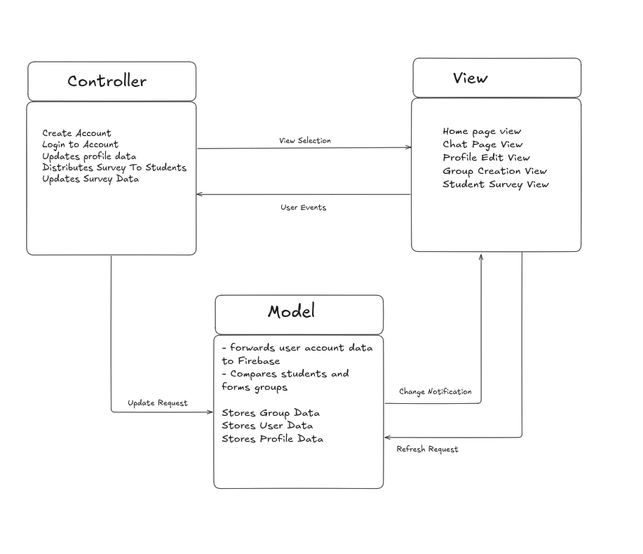

Design Description:
The architectural pattern consists of three components: the view, the controller, and the model.
The view for our app handles the UI of the web application. This is mostly handled by [React and Bootstrap]. The application has several views: the Home Page view, Profile Edit view, Group Creation view, and Student Survey view. Instructors use the Group Creation view to set up a class and review proposed groups. Students use the Student Survey view to give their availability and preferences, and the Home Page view to see their assigned group. Any interaction with the UI can trigger user events, sending information to the controller to handle the inputs. The view also sends a refresh request to the model when a screen needs the latest data.
The controller handles the various events from the view. These events can be logging in or out of an account, creating an account, updating a profile, submitting a survey, or creating and reviewing groups. The AccountController, ProfileController, SurveyController, and GroupController handle them. When an input is detected, the controller sends a view selection to the view to show the right screen, and sends an update request to the model for any state changes. For example, when a student submits the survey, the SurveyController passes the answers to the model.
The model for our app handles the data and the grouping logic. It contains the UserModel, ProfileModel, SurveyModel, and GroupModel, which store user, profile, survey, and group data, plus a MatchingService that compares students’ survey responses to form groups. It uses a FirebaseClient to forward user account data and all stored data to Firebase. Any state changes sent by the controller are stored in Firebase, and the model sends a change notification to the view when data changes, such as when groups are published. This communication between the database and the view is what keeps the information on the application up to date.
Other model-layer libraries: Firebase.

